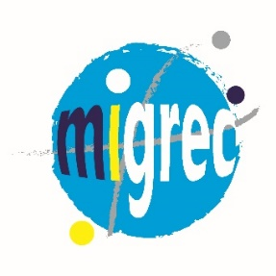 | 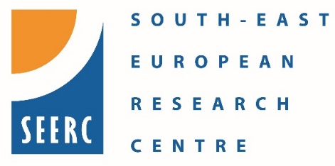
Second training workshop in applying for external research funding with emphasis on Erasmus+ and HORIZON EUROPE MSCA (Marie Marie Skłodowska-Curie Actions)
Agenda
April 6, 2022
First session 10.00 – 11.30
- Overview of Erasmus+
  - Erasmus+ KA2
  - Jean Monnet Actions
Coffee break 11.30 – 11.45
Second session 11.45 – 13.00
- HORIZON Europe MSCA
  - Doctoral Networks
  - Post Doctoral Fellowships
  - Academia – Staff Exchanges
  - Co-funding of regional, national and international programmes
Lunch break 13.10 – 14.00
Third session 14.00 – 15.00
- Detailed presentation of MSCA Doctoral networks
  - Key features of the proposal
  - Consortium construction
  - Evaluation criteria
Coffee break 15.00 – 15.15
Fourth session 15.15 – 17.00
- Groupwork: Key elements of a MSCA Doctoral network proposal focusing on Migration
- Open Discussion
- Main take-aways

